IS487 Emerging Topics in IS

Week 01 – Lab: Introduction to Flutter

Lab Objectives
By the end of this lab, students will be able to: - Set up the Flutter development environment - Create and run a basic Flutter application - Understand the Flutter project structure - Modify UI widgets in main.dart

Prerequisites
- Basic understanding of mobile applications
- Android Studio installed
- VS Code installed
- Flutter SDK installed and added to system PATH

What You Will Build
A simple Flutter mobile application that displays a welcome message and a counter button. The app will show text in the center of the screen and increment a counter each time a floating action button is pressed.
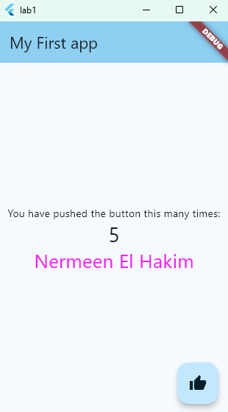

Step 1: Verify Flutter Installation
- Open Command Prompt or Terminal (ctrl + ~ ) .
- Run the following commands:
- flutter --version
dart --version
flutter doctor
- Ensure there are no critical issues reported by flutter doctor.

Step 2: Create a New Flutter Project
- Open VS Code
- Go to View Command Palette or Press Ctrl + Shift + P
- Type: “Flutter: New Project”
- Select Flutter Application
- Choose folder
- Name your project: “is487_lab1”
- Wait until project opens

Step 3: Explore Project Structure
Review the following important files and folders:
- lib/main.dart – Main entry point of the application
- pubspec.yaml – Project dependencies and metadata
- android/ – Android-specific files - ios/, web/, windows/, linux/, macos/ – Platform-specific folders

Step 4: Modify main.dart
- Open lib/main.dart.
- Locate the Text widget that displays the counter description.
- Replace the text with:
- You have pushed the button this many times
- Change the app title to:
- My First App

Step 5: Customize the UI
- Change the FloatingActionButton icon from Icons.add to Icons.thumb_up.
- Change the theme color.
  - Inside theme: ThemeData
  - Change the seed color to any color of your choice from the palette.

- Ensure the text is centered using Center and Column widgets.
Explanation:
- Center → centers the Column on the screen
- mainAxisAlignment.center → centers children vertically
- crossAxisAlignment.center → centers children horizontally
  - Explore the body and note the center alignment.

Step 6: Run the Application
- Click Run ▶ Start Debugging.
- Choose windows
- Verify that:
  - The app launches successfully
  - The welcome message is displayed
  - The counter increments when the button is pressed

DIY

- Add another Text widget with your name
- Change the text color and font size

  - Tip: press ctrl + space to see the options you have.

Lab Task (Submission)
Students must submit on moodle: - Screenshot of the running app showing all widgets

IS487 Emerging Topics in IS

Week 02 – Lab: Flutter Widgets & Layouts

Lab Objectives
By the end of this lab, students will be able to: - Understand the concept of “Everything is a Widget” - Use common Flutter widgets such as Scaffold, AppBar, Container, Row, and Column - Differentiate between Stateless and Stateful widgets - Apply layout concepts including alignment, padding, margin, and Expanded widgets

Prerequisites
- Completion of Lab 01 – Introduction to Flutter
- Flutter SDK properly installed
- Android Emulator or physical Android device
- Basic understanding of Dart and Flutter project structure

What You Will Build
A simple Flutter application that displays: - An AppBar with a title and icon - A centered layout containing text and an image - A Row and Column layout demonstrating alignment - Proper spacing using padding, margin, and Expanded widgets

Step 1: Open Existing Flutter Project
- Open Android Studio.
- Open the Flutter project created in Lab 01.
- Run the project to ensure it works correctly.

Step 2: Update AppBar
- Open lib/main.dart.
- Locate the Scaffold widget.
- Modify the AppBar as follows:
  - Set the title to: IS487 – Widgets & Layouts
  - Add a leading icon using Icons.menu
  - Add one action icon using Icons.info

Step 3: Create a Column Layout
- Inside the body of Scaffold, use a Center widget.
- Add a Column widget as its child.
- Set mainAxisAlignment to MainAxisAlignment.center.
- Inside the Column, add:
  - A Text widget displaying: Everything is a Widget
  - A second Text widget displaying your name

Step 4: Use Container and Styling
- Wrap one of the Text widgets inside a Container.
- Add the following properties to the Container:
  - Padding: 16
  - Margin: 10
  - Background color
  - Rounded border radius

Step 5: Add a Row with Expanded Widgets
- Below the Column, add a Row widget.
- Inside the Row, add three Container widgets.
- Wrap each container with Expanded.
- Assign different flex values (1, 2, 1).
- Give each container a different background color.

Step 6: Add an Image Asset
- Create a folder named assets/images in your project.
- Add a square image to this folder.
- Update pubspec.yaml to include the assets folder.
- Display the image using the Image.asset() widget.

Step 7: Handle Screen Overflow
- Wrap the main Column widget with SingleChildScrollView.
- Run the app and verify there is no overflow error.

DIY
- Convert one widget into a StatefulWidget
- Add a FloatingActionButton that shows a message using SnackBar

Lab Task (Submission)
Students must submit on moodle: - Screenshot of the running app showing all widgets -

